UML Diagrams

Problem Statement:
Enhancing company registration security by implementing real-time camera-based age and gender verification to prevent fraudulent entries. Version 1.0 approved
Company Details –
Organization: Senim Solutions LLP
Name: Pravin Pawane Position: CEO pravin.pawane@senim.in
Location: Bhosari , Pune
Prepared by ,
Omkar Londhe 202301040027
Yashraj Jagtap 202301040092
Ishwari Mahajan 202301040173
Om Thorat 202301040155
Sumit Khetre 202402040017
Sneha Nannaware 202301040267
15/03/2026
- Use Case Diagram

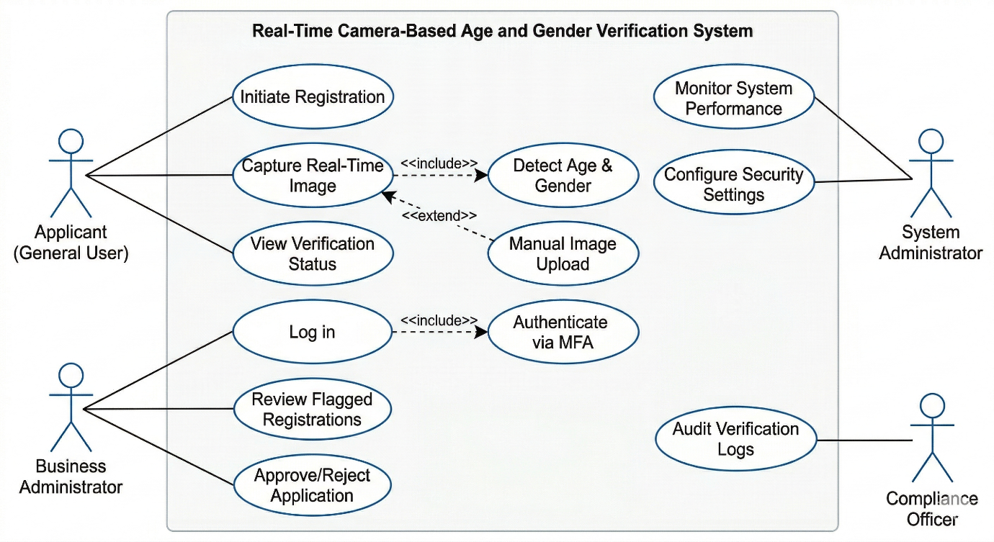

- Activity Diagram
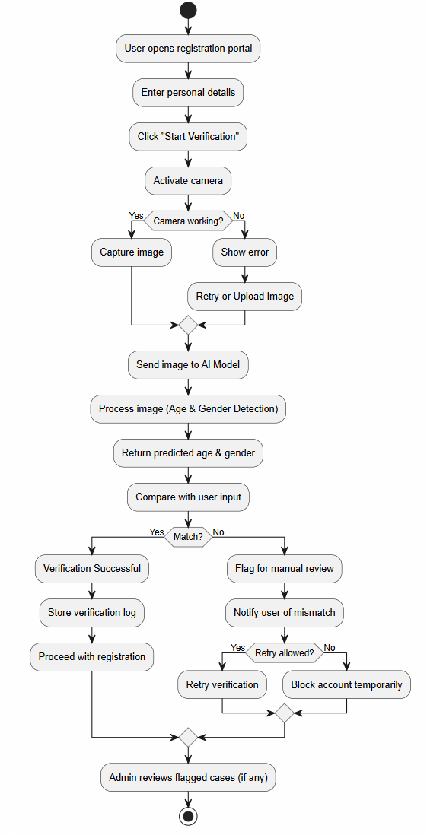

- Class Diagram

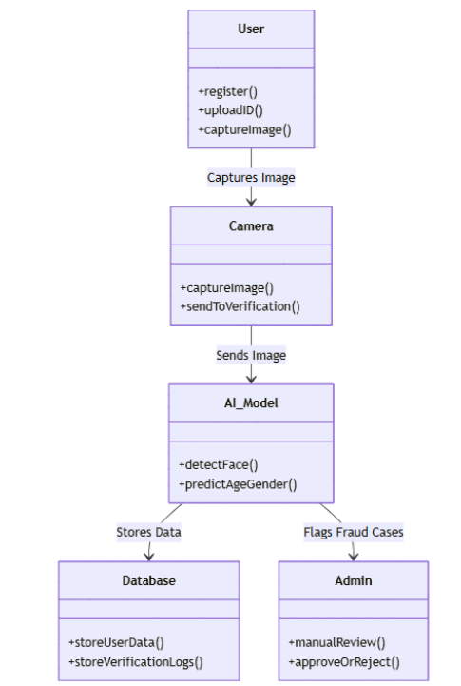

- Data Flow Diagram

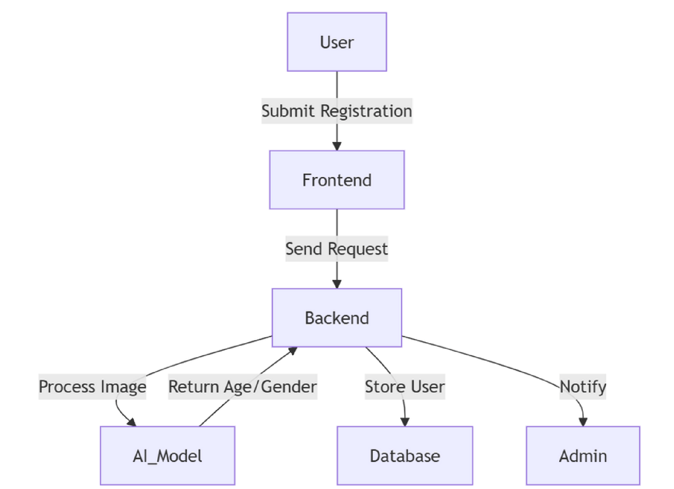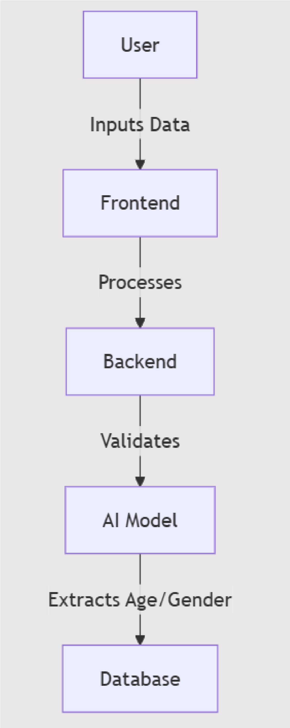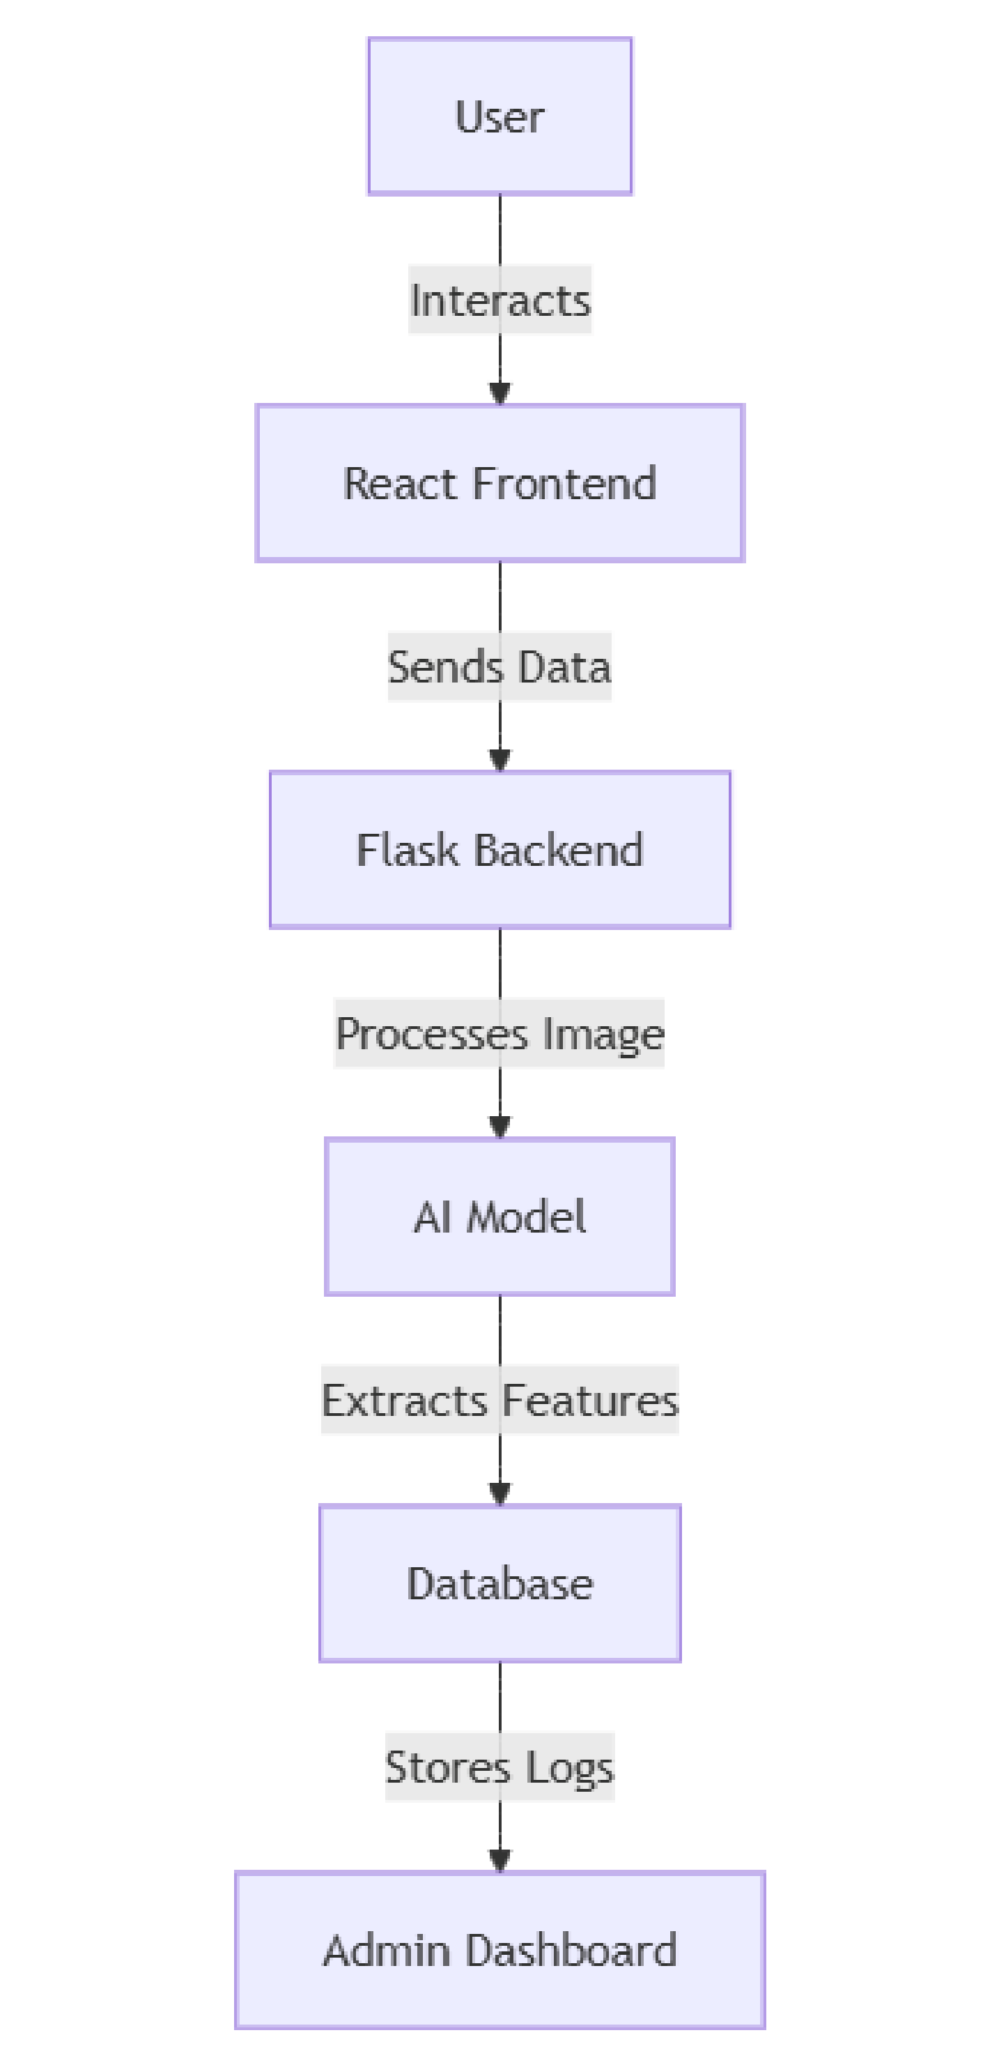
(
DFD - Level

- Sequence Diagram

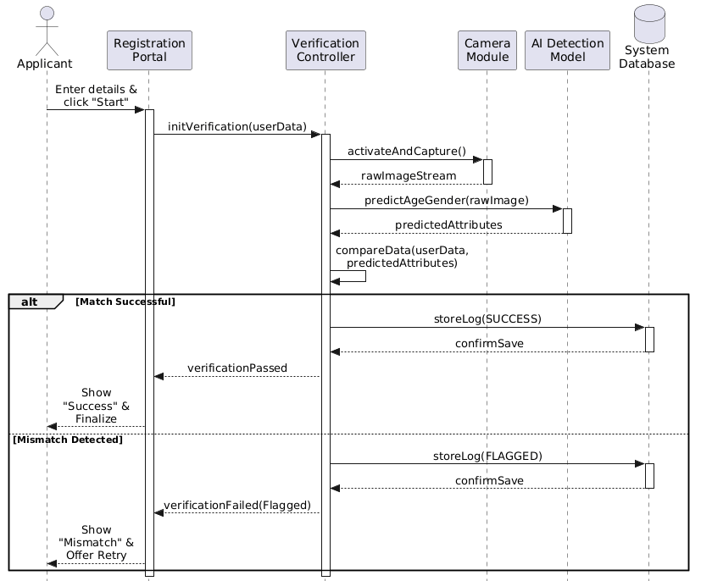

- Object Diagram

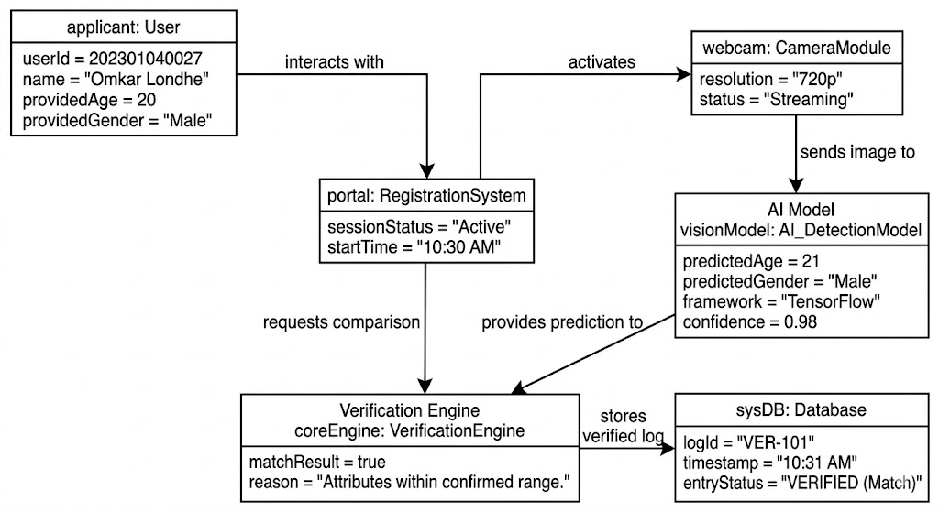

- Deployment Diagram
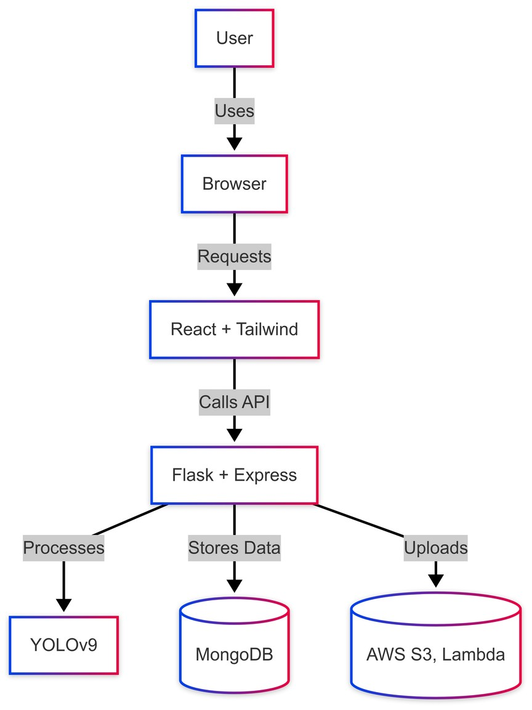

10. Timing Diagram :
